Kristiania/Oslo – a New Mark

Mike Dovey reported in the TPO-Journal No.341, Autumn 2018, Page 78 as follow:

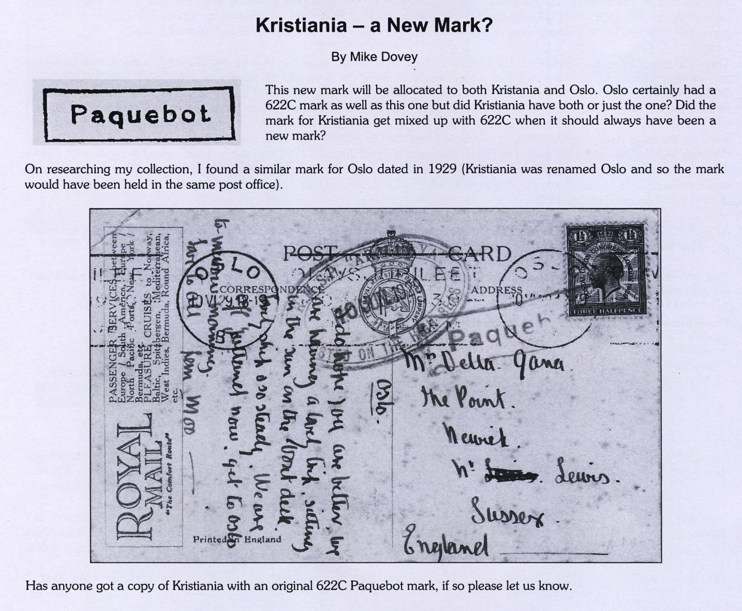

What is the difference of the new mark to the Oslo 622? Therefore a small picture.

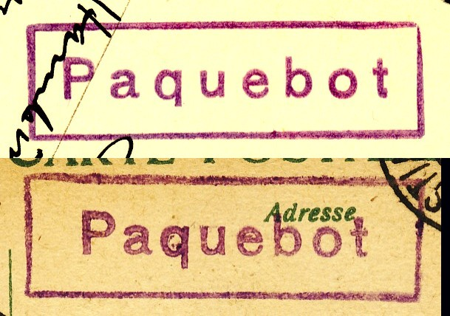

The upper figure shows the Oslo 622 mark the lower shows the new one.

Alan Totten gaves a short description in his article “World War I Paquebot mark
from Kristiania” published in the TPO-Journal No. 342, Winter 2018, Page 107 and
partly displayed here.

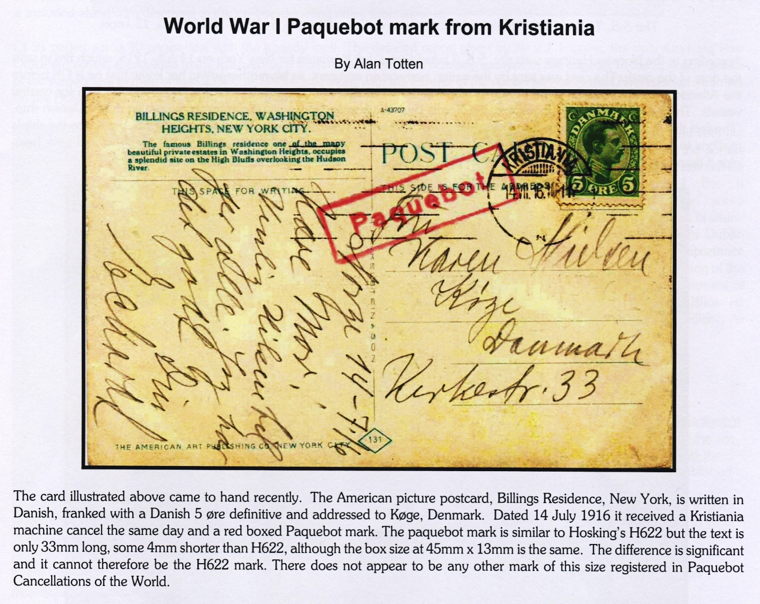

It is clear visible that the word Paquebot is shorter in the new mark.

The next question is the time interval of usage. Therefore some examples :

The first figure shows a card written on 29.3.12. The Paquebot mark is the only one
sign of postal handling. The written text started with “Kristiania…”. Therefore it can
be assumed that the card has been posted in Kristiania. This card shows the earliest known usage for the moment.

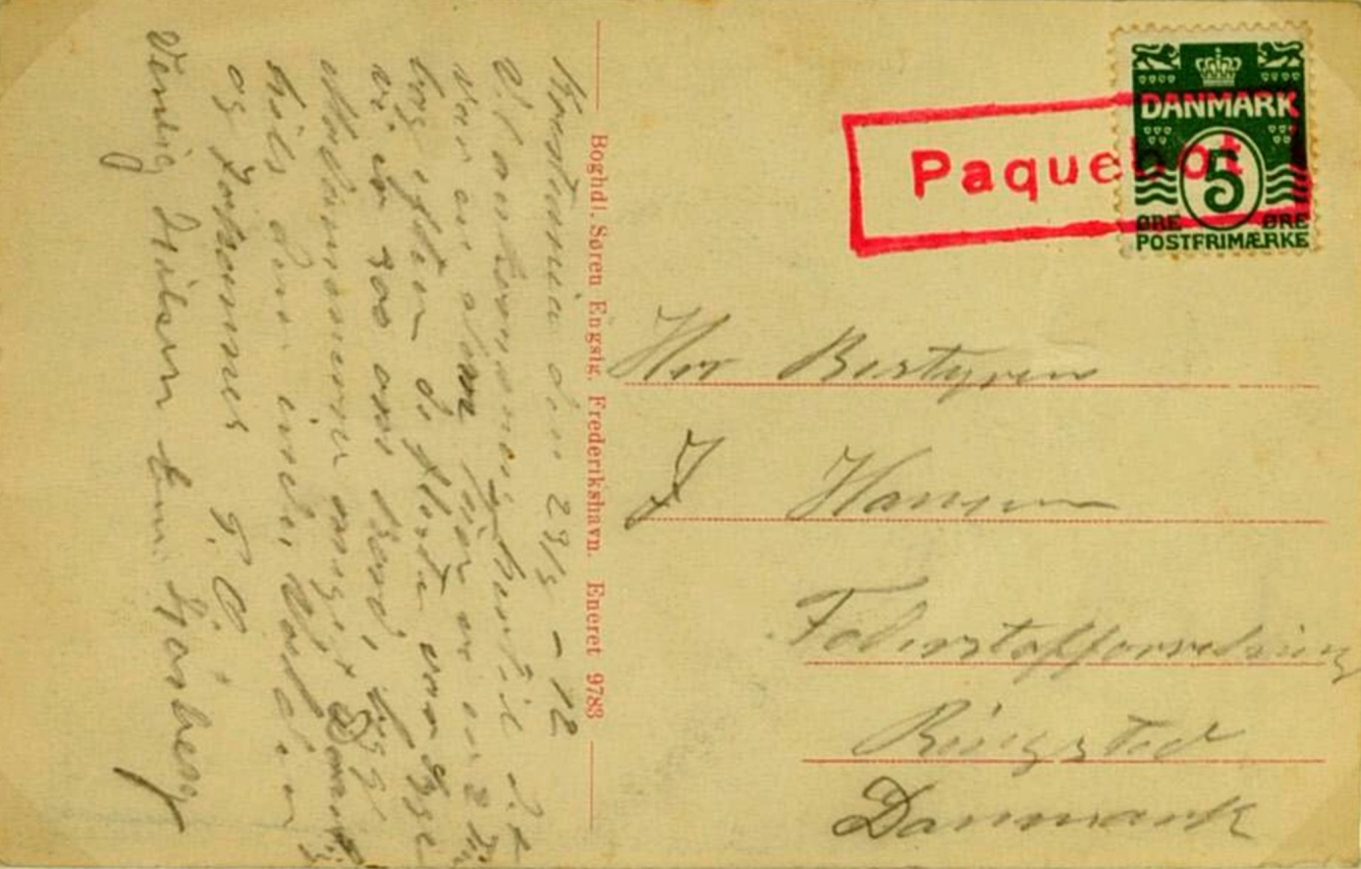

The second piece is from my own collection and dated 15.VII.14.

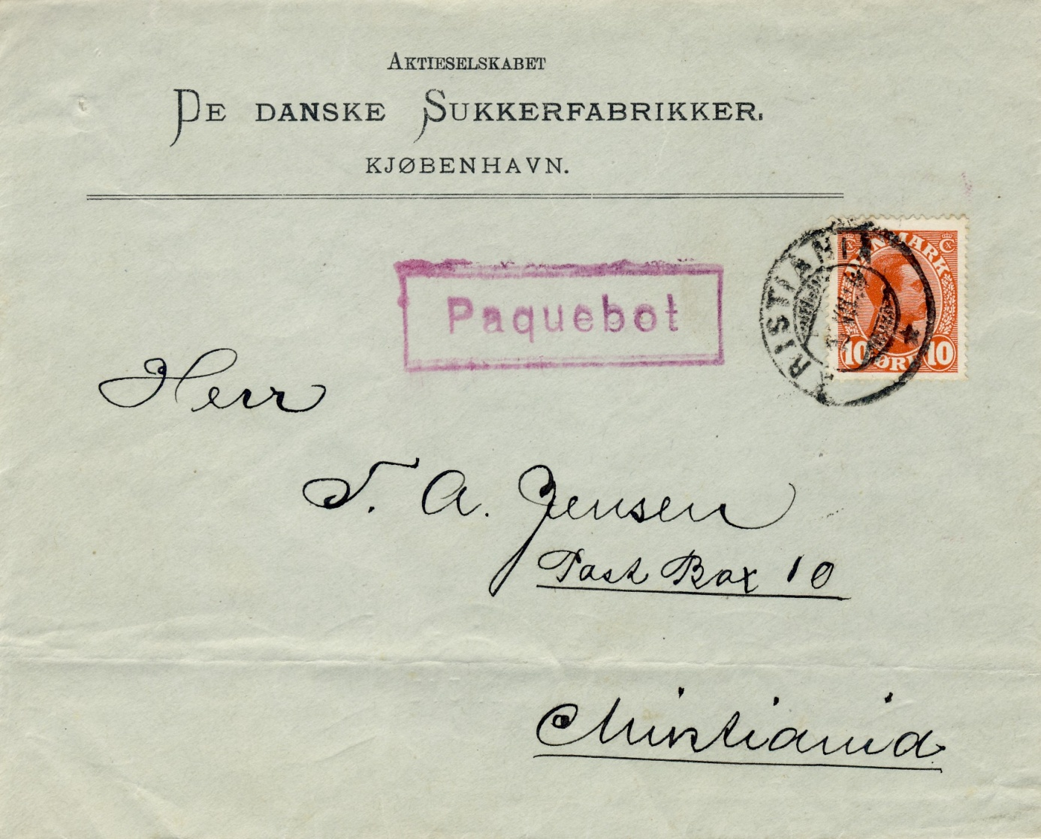

The third picture shows the latest item of the Kristiania cancel and the new Paquebot
mark (for the moment)because from 1. January 1925 Kristiania was named Oslo.

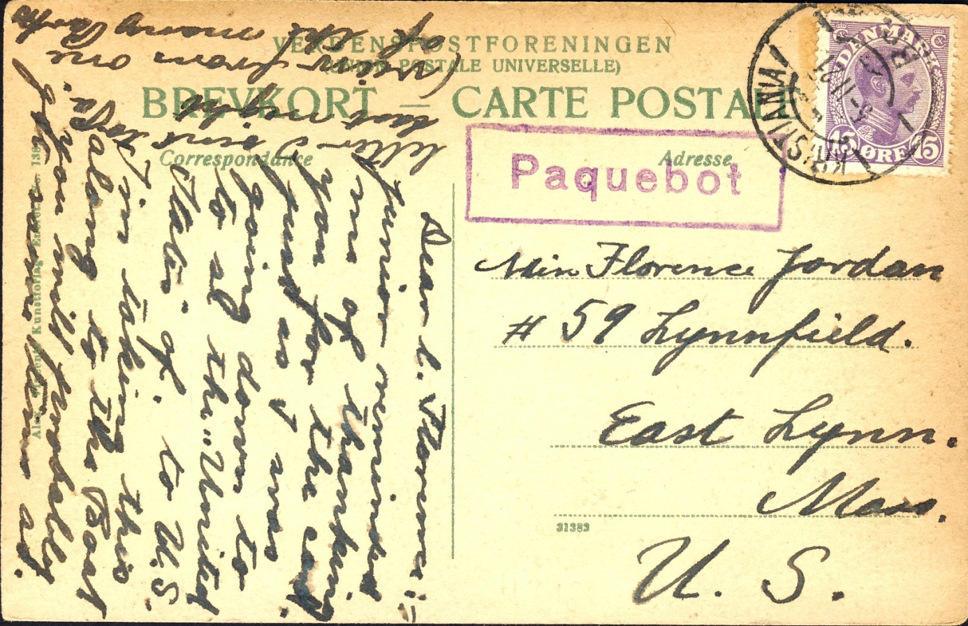

The card with destination USA has been cancelled on 5-11 21.

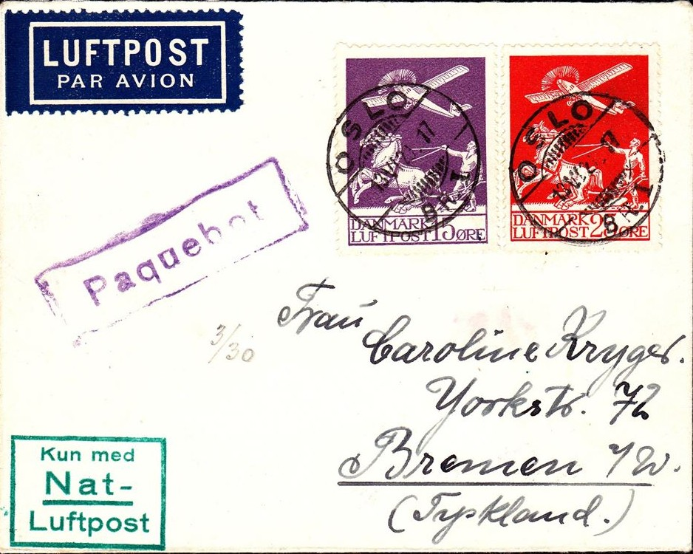

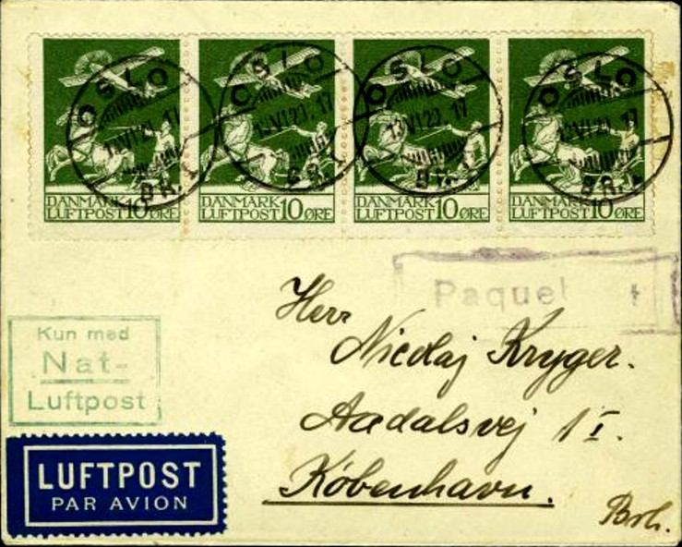

The two Air Mail covers above have the same date, were cancelled with the new
Paquebot mark and were postally handled in Oslo.

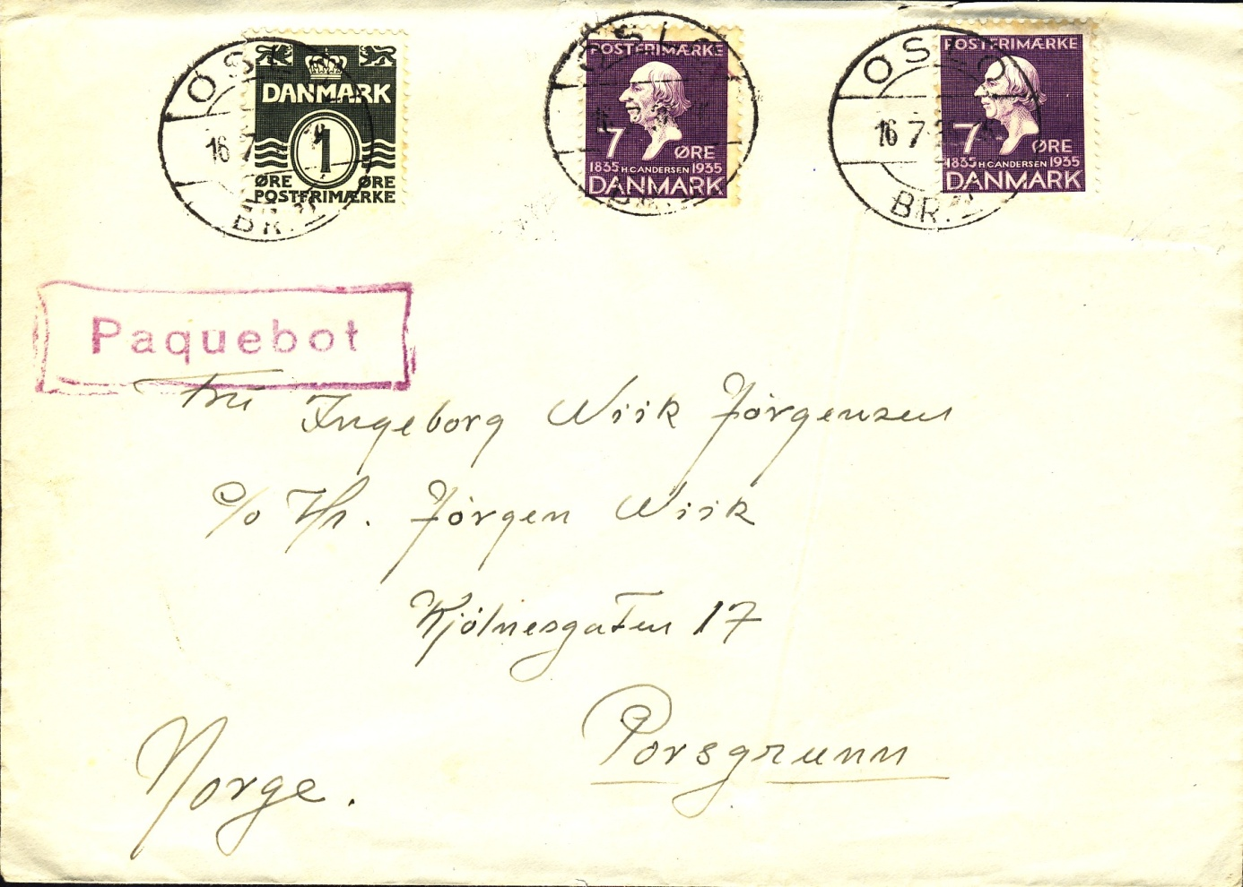
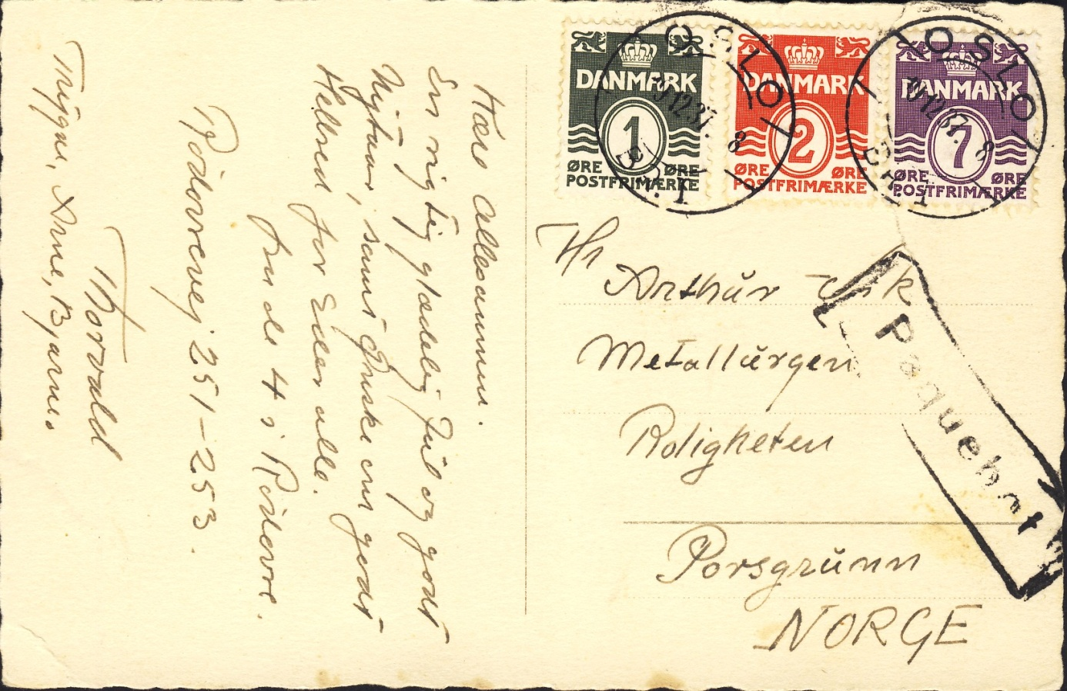

The forelast item dated 16.7.36 and the last card dated 19.12.37. On the last figure
is the Paquebot marks wear obvious. Probable is this cancelletion one of the last in
this marks live.
In conclusion of the available items can be stated that the mark was in use from
1912 till 1937.
But further research brings certainly better insights.

The Oslo 622 mark was in use since 1931. Therefore it is extrem unlikely that we
ever see an item cancelled in Kristiania and marked by the # 622.

5th January 2018 Peter Schulz

