China Steamer Letter Boxes

By Mike Dovey

The most fantastic thing about collecting postal history, and maritime especially, is that you really never know what new surprise is waiting just round the corner. Avid collector Peter Schulz in Germany saw this and knew that it was something not seen before and so another Paquebot cancellation is to be added to the ever growing list compiled to date

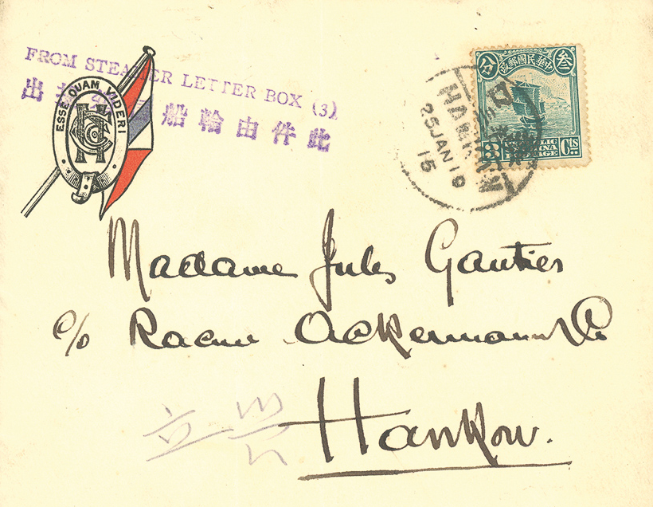
Hankow – a new cancel

At first glance it is no more than a superb strike of a “FROM STEAMER LETTER BOX” posted and delivered to an address in Hankow, an envelope to make the onlooker salivate and want to add to any good collection of Far East marks but then once you have got over the first glance and looked a bit deeper then the collector picks up the fact that the mark has an index 3 and that poses a bigger question.

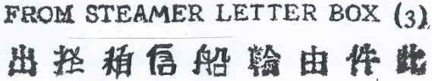 | Dated 1915 with an Index 3

A quick look in the 4th Edition of the Paquebot book (if you haven’t got a copy you are missing out and so contact the Society for availability of the new DVD) shows that there are two near identical marks issued at Nanking (index 10) and Canton (index 12), this begs the question that if we now have three index numbers then it must be that there are other cancels issued to other Chinese port post offices with the other missing nine numbers.

 | 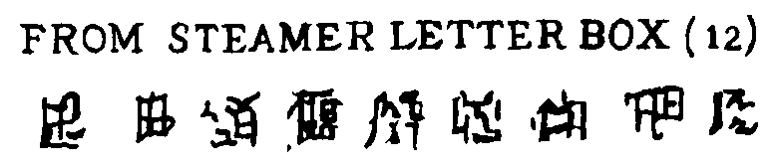
Nanking 3267D (1925) | Canton 3054E (1921-25)

The Chinese writing for index numbers 3 (Hankow) and 10 (Nanking) are virtually identical and so we have to assume that the writing for index 12 (Canton) is the same but has been wrongly copied probably due to the fact that the original envelope was a poor strike and so a bit of creativity was needed. All we have to do is find someone to read the Chinese characters and if Canton should be like the other two then a change will be necessary.

The question now is whether these three marks are three of a dozen or even, with the number of ports in China, three of even more. The race is now on the try to fill in the missing gaps which could take a lifetime. Alas my timeline is a tad shorter than I would like so I better get a move on but maybe one of the members reading this article can help ?

My sincerest thanks to Society member Peter Schulz for his help by finding and reporting this item.

