Paquebot-Mail is Still Alive - in Tristan da Cunha!
By Hans U Born
In recent years I have tried many times to mail Paquebot letters while on a cruise. The losses were close to 90% depending on the ports. In the time of emails, the main explanation is that both the postal authorities and the ship’s crew no longer are aware of these – at least for philatelists highly interesting – possibilities.
Therefore, I had given up to mail items this way on cruises.

However, I have changed my mind, when the most remote inhabited island was on my list of ports of call: Tristan da Cunha.

This was the case during my cruise from Ushuaia to the Falkland Islands, South Georgia, Tristan da Cunha and Cape Town. Before the start of the cruise I had contacted the Tristan Post Office by mail, to ask, if they still have a Navire postmark and know to handle such mail. I received a very friendly mail from the Tristan Post Mistress confirming both.

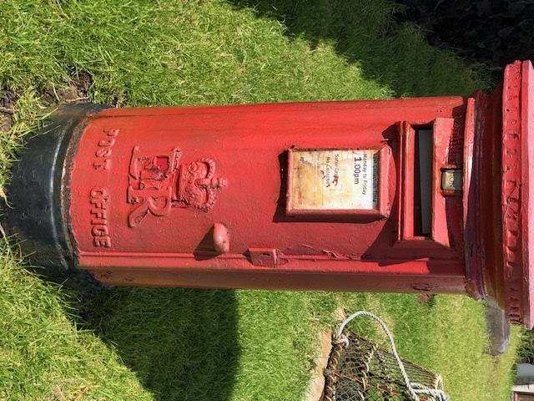

We were very lucky that we could land on the island by zodiacs from our small cruise ship, which is not guaranteed weather wise. The short walk from the small harbor to the Post Office got me in touch with Iris Green, the Postal Mistress, and she was happy to apply the Navire postmark on both my covers with Bahamas postage (the ship is registered in Nassau/Bahamas) and those with South Georgia postage mailed in South Georgia waters. The last port of call before Tristan was King Edward Point on South Georgia, where the old whaling station Grytviken is located. Grytviken is now managed by the Government of South Georgia. There is a British research station and a Post Office.

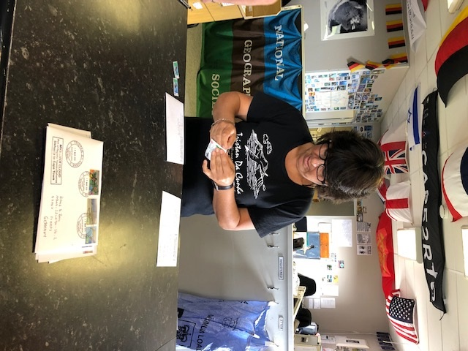

The Navire postmark now in use is a new and until now not recorded self-inking stamp giving very clear impressions. It was introduced on May 2nd, 2018 according to the Post Office and replaced a similar one in use between 2004 and 2018.

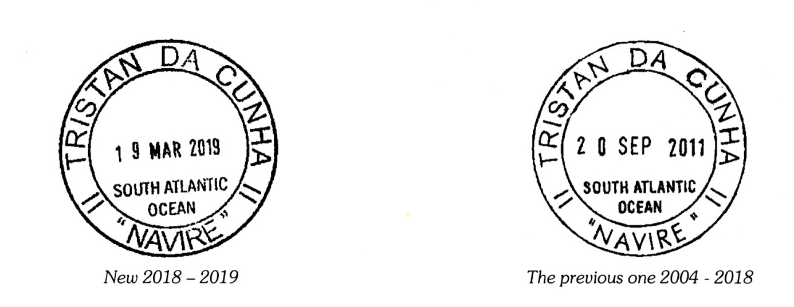

Note: Both of these marks are new and are not recorded in the 4th Edition of the Paquebot book and so at this moment they have not been credited with new Paquebot numbers, however in due course they will have numbers attributed when hopefully the addenda to the 2010 book will published.

