**Open questions about the stamp Tschifu 6818**

In the summer 2002 D.F.Collins provided a card with this stamp

in the TPO&Seapost Journal on page 59. This card was postmarked on 11.7.8 in

Vladivostok - see picture below.



There is a second postcard with this cancellation with

the Mi-No. 28 and the datestamp of TSCHIFU from 17.8.08 on the

picture page - see picture below.

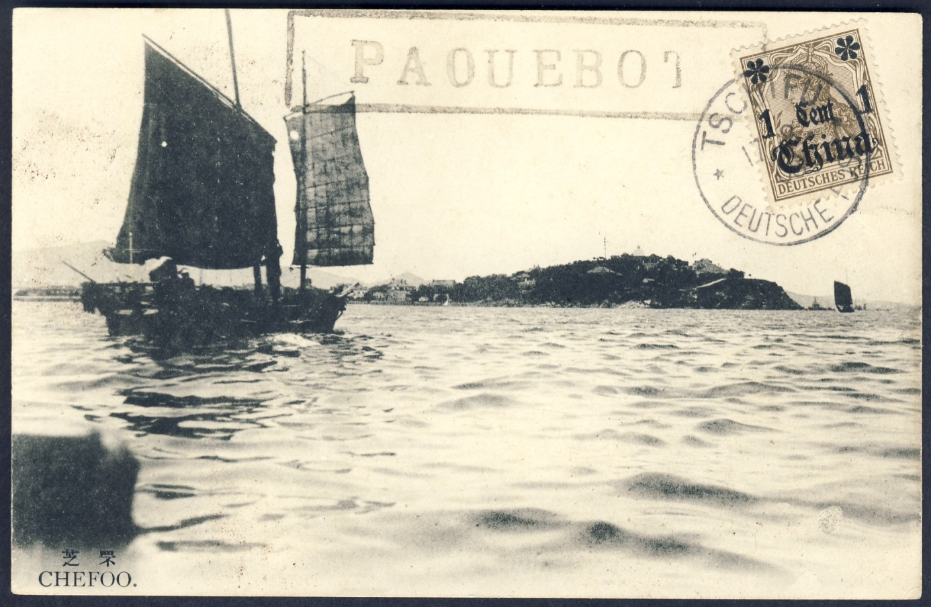

On the back there is only an address in France - see picture below.

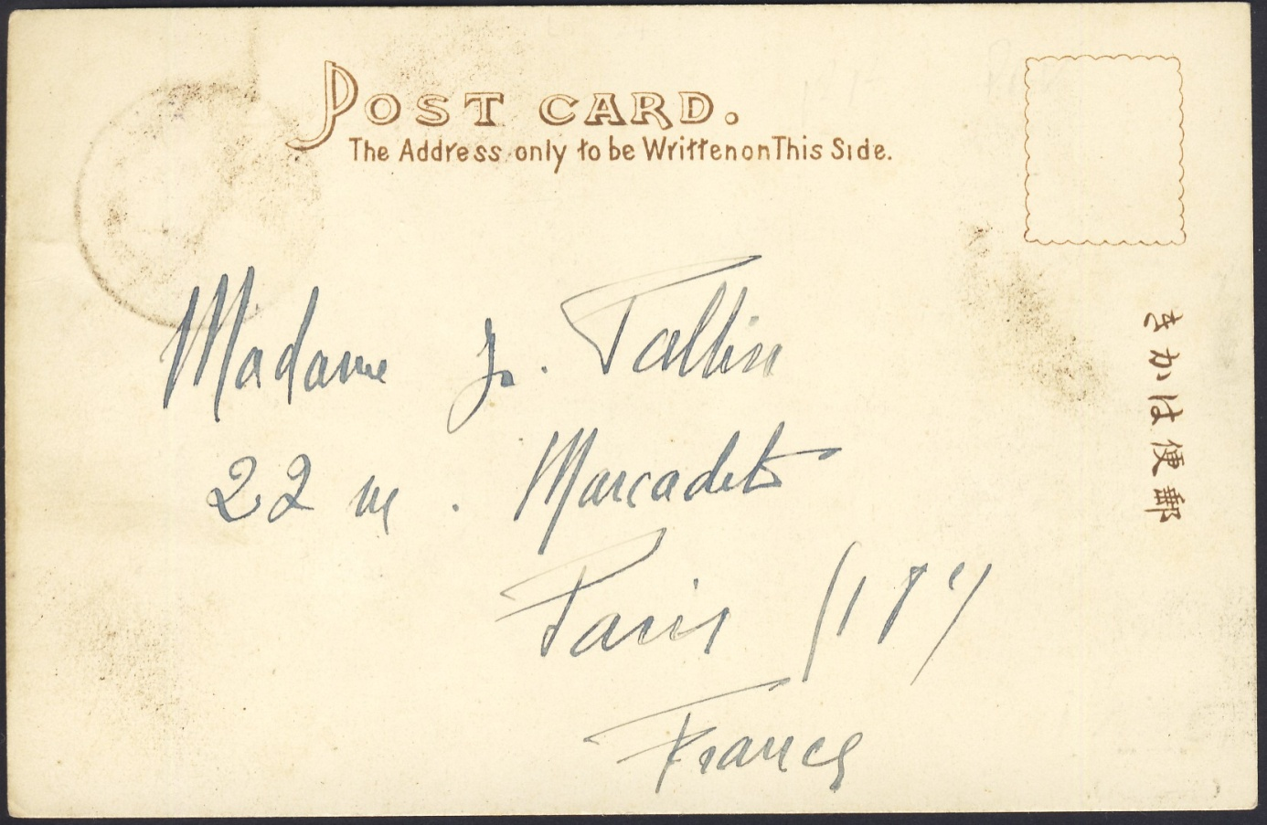

The third item is a greeting card with the 2-cent stamp of Kiautschou,

Mi-No. 19, on the picture page and the TSINGTAU cancel dated on the

21 9 08. On the text page is again an address in France – see picture below.

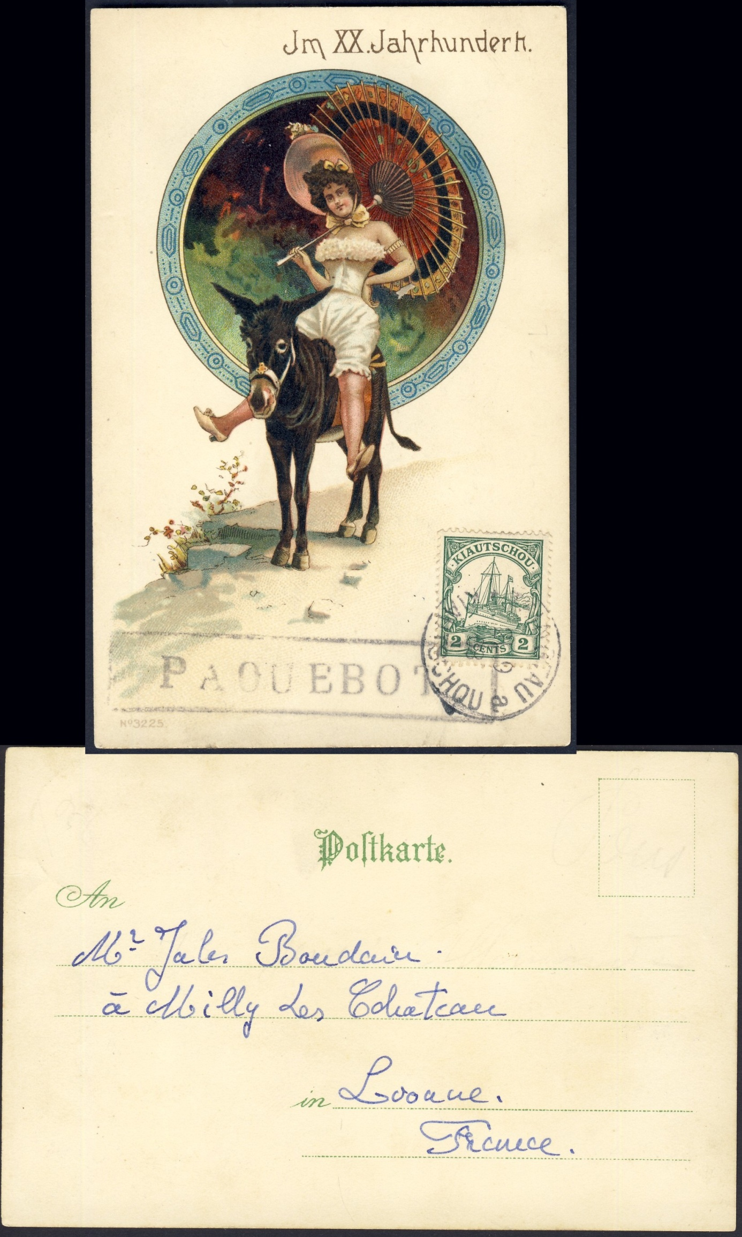

In conclusion it can be said that the Paquebot mark, which is assigned in the catalogue to the port Tschifu (Chefoo), probably cannot come from the post office formerly located there, because it can also be found on PPC from Vladivostok andTsingtau.

Following the chronological order of the postmark data one could assume that

the cancellation could also be assigned to a ship, which is on southbound route

from Vladivostok via Chefoo and Tsingtau.

It can also be presumed if the thesis with the ship's route is valid, whether the postmark was postmarked by the ship's postal officer or by a traveler with

maybe a philatelic interest.

For a better clarification of the origin of the stamp, it would be good to know if

the port sequence Vladivostok 11.7.8

Chefoo 17.8.08

Tsingtau 21.9.08

allotted to a certain ship.

Maybe a collector somewhere knows more about it or have other examples of that mark.

If anyone can help with any information about these dates and the cancellations

then I would greatly appreciate any help you can give me and I thank you in advance for any such input.

October 2019 Peter Schulz