Blyth-Ship-Letter Mark on French Stamp

At the end of the 19th century, the working and living conditions of fishermen on the North Atlantic and its tributaries were miserable. There were frequent accidents at work and fatalities were not uncommon.
The "Societe des Oeuvres de Mer", founded in France in 1895, wanted to change these conditions and provide better social and medical care for the fishermen on the fishing grounds.
The three-masted schooner "SAINT-PIERRE", which had been converted into a hospital ship, sailed the fishing grounds in the North Atlantic to provide help and assistance on the spot.
In 1910, the "Societe des Oeuvres de Mer" bought the former trawler "OCCIDENT" and had it converted into a 43 m long hospital ship, which was given the name "NOTRE DAME DE LA MER". From 1911 to 1914, this hospital ship and its 22 crew members were in service in the North Atlantic, including off Iceland.

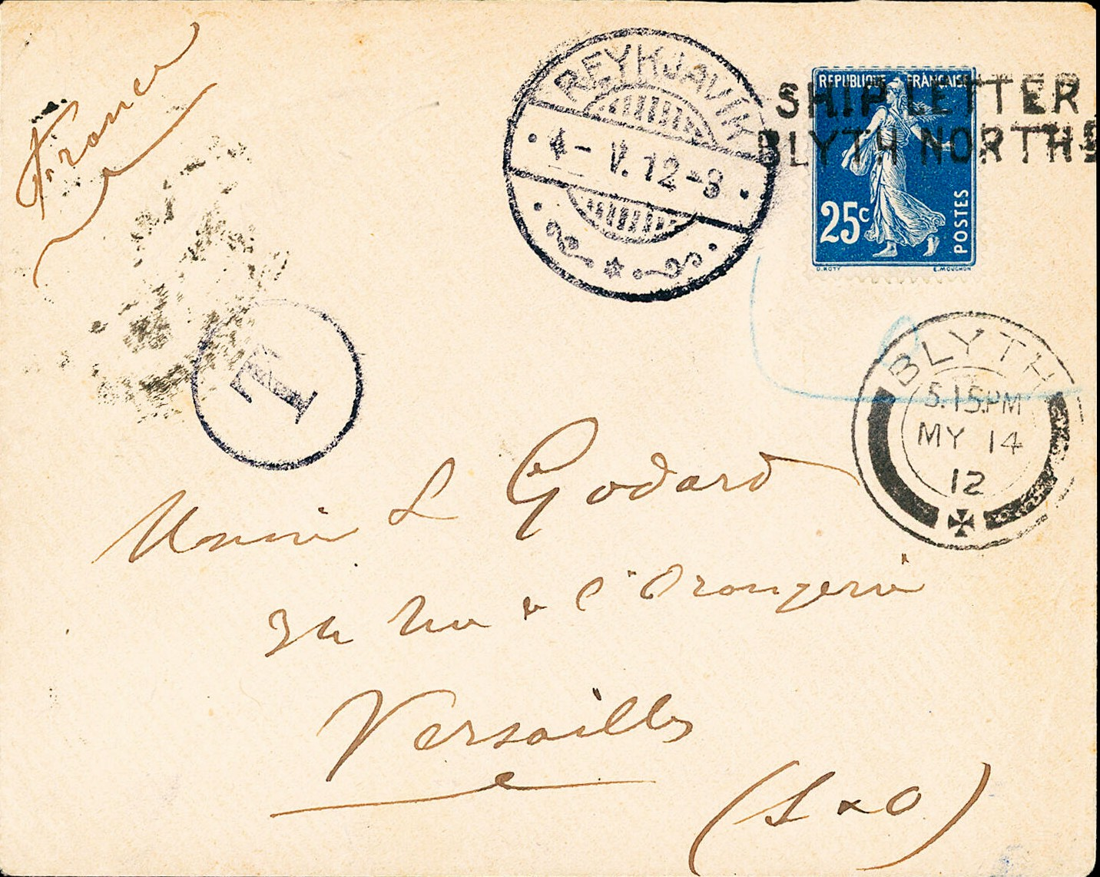

The present letter, franked with a 25 centimes stamp, was posted in Reykjavik.
The postal clerk refused to cancel the French stamp (blue border around the stamp) and affixed the circular tax mark. He placed the daily postmark of Reykjavik, 4.V.12, next to the stamp. The letter was then handed over to another ship which carried the mail from Iceland to England. In Blyth (Northumberland) the letter then receives the day postmark of MY 14 12 and the stamp is cancelled "SHIP LETTER / BLYTH NORTH D".
Two days later, on 16-5 12, the letter receives the arrival postmark at the destination of Versailles on its reverse side.
So, despite the zeal of an Icelandic postal official, the letter arrived in Versailles without a surcharge being levied.

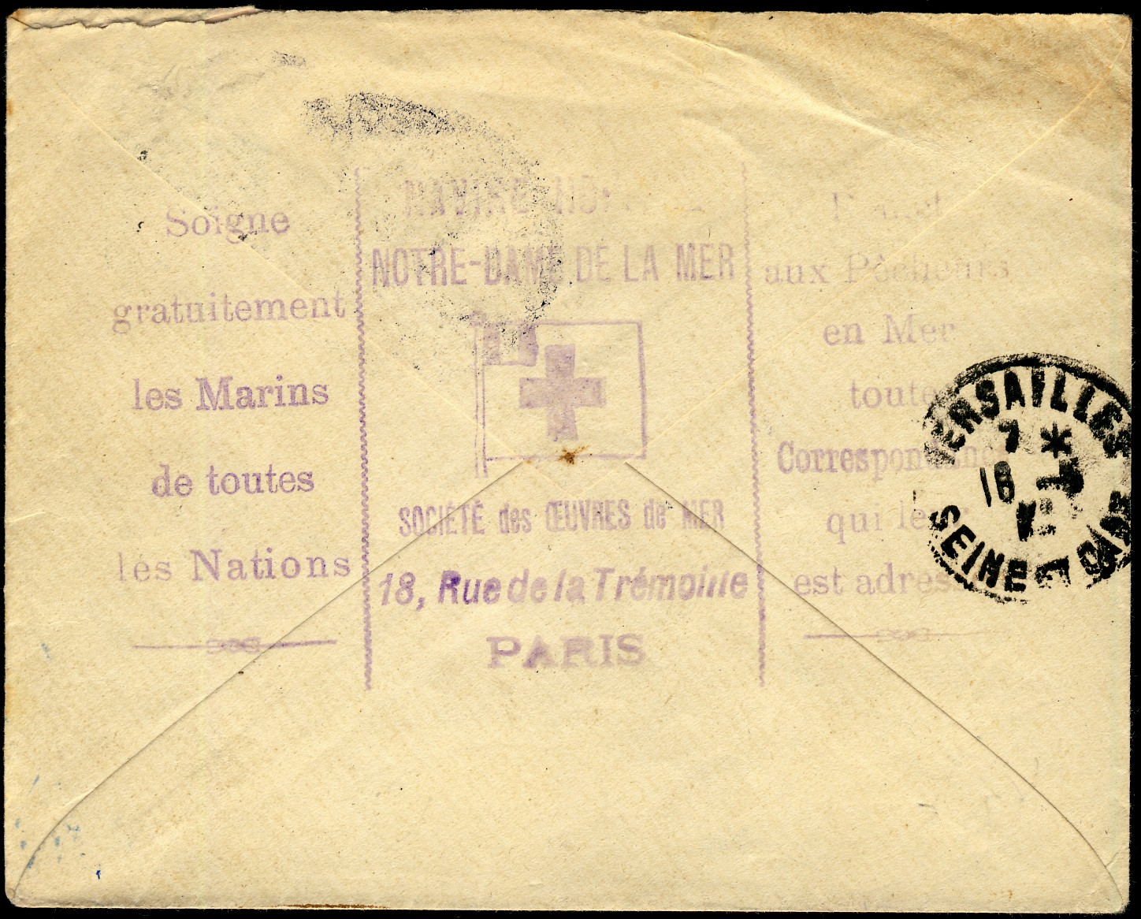

The most remarkable thing about this letter is the cancellation on its reverse side, which indicates in its centre the origin of the hospital ship "NOTRE DAME DE LA MER" and the "Societe des Oeuvres de Mer" as its owner. The texts to the left and right of the centre briefly name the services offered by the society, among others. According to reports, there are only three covers in total bearing this stamp, of which this one is the best preserved. A certainly quite extraordinary ship's mail cover!!

January 2023 Capt. P. Schulz

