Iceland Postcard
Kirkjubæjarklaustur, Breiðabólsstaður Á Síðu and Queenstown Wilbur Jónsson FRPSL
The postcard illustrated here is unusual in that it served a commercial purpose. Dr. Bjarni
Jensson, practising in the Síða district which includes Holt á Síðu, Breiðabólsstaður á Síðu and Kirkjubæjarklaustur (once the site of a nunnery), writes to the pharmaceutical firm Goedecke and Co. in Leipzig asking (in translation from the Danish): “I would very much like to receive some Anusol suppositories for research work” and signs himself “Bjarni Jensson, Sida, Island” using the unaccented ‘i’ and Danish ‘d’ rather than the Icelandic ‘ð’ in the spelling.
Note: there are at least twenty four places named Holt and eleven named Breiðabólsstaður in Iceland, hence the modifier ‘á Síðu’. The date stamp for Kirkjubæjarklaustur has the post office name misspelled in the canceller.

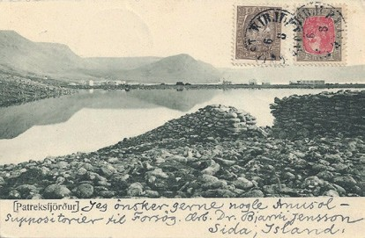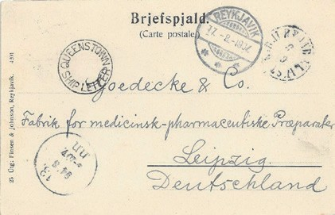
The postcard was accepted at Kirkjubæjarklaustur on 6 August 1907, arriving in Reykjavík on 17 August 1907. It was included in a mailbag carried by a German battle cruiser which stopped at Reykjavík and continued on to Queenstown (now Cobh in Eire) where the card received the circular ‘QUEENSTOWN SHIP LETTER’ cachet as a transit mark.
Mike Tuttle in his article “Mail from Iceland with a Queenstown Ship Letter Mark” in Scandinavian Contact Vol. 22 No.1 pp 30-32 states:
Most of the 30 (or so) Iceland covers known with this mark come from the crew of the German Battle Cruiser SMS Freya which left Kiel on 19th July 1907 on a training cruise, calling at Christiania (now Oslo), Balestrand (both in Norway), then Reykjavík on or about the 12th August. The vessel left on the 16th or 17th, because the captain was paid six Icelandic Kroner by the Icelandic Post Office to convey mail to the next port of call. This mail was cancelled Reykjavík 13th, 14th, 15th and 16th August, but some of the marks are faint.
The next port was Queenstown.
Previous to the discovery of a batch of Icelandic mail with this mark by a German dealer some thirty or so years ago, only one card had been recorded with this ship letter mark and that had a Spanish franking (illustrated in Robertson’s Ship Letters). The mark should now be considered somewhat scarce, rather than rare.
Bjarni Jensson was born in Reykjavík on 9 January 1857 and died there on 5 September 1930. He finished his studies at Lærðaskóli in Reykjavík in 1878, and then went to the medical school in 1882. From there, he continued his training at a hospital in Copenhagen during 1882, and in 1883 returned to Iceland to serve as a country doctor in various parts of the island. There were two

124 – 478 LONDON PHILATELIST 1431 2015

periods when he served in the Síða district and lived at Breiðabólsstaðir á Síðu, namely 1894 to 1898 and again from August 1899 until July 1914. His father, Jens Sigurðsson, was a head teacher at Lærðaskóli when the school moved back to Reykjavík from Bessastaðir and later served as the third Rektor of the school after the move. His mother Ólöf was the daughter of Björn Gunnlaugsson, the man who made the first modern land survey of Iceland and participated in publishing the first accurate map of the country in 1849. Regrettably none of the places mentioned here as being in the Síða district appear on his grandfather’s map. I am indebted to my cousin Dr Steinn Jónsson for supplying me with this information about Bjarni.

LONDON PHILATELIST 1431 2015 124 - 479

