Pictures of some Paquebot Handstamps

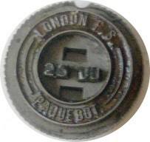

London No. 145, used 1971 – 1990

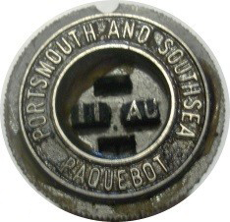

Portsmouth No. 191, used 1953

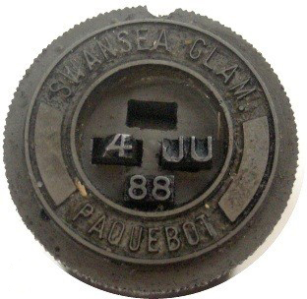

Swansea No. 260, used 1935 – 1975

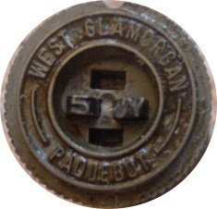

Swansea No. 261, used 1976 – 1979

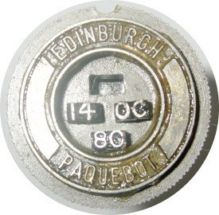

Edinburgh No. 283, used 1938 – 1996

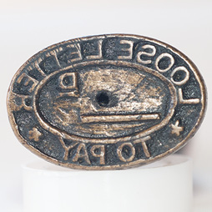

Strahan No. 5817, used 1905

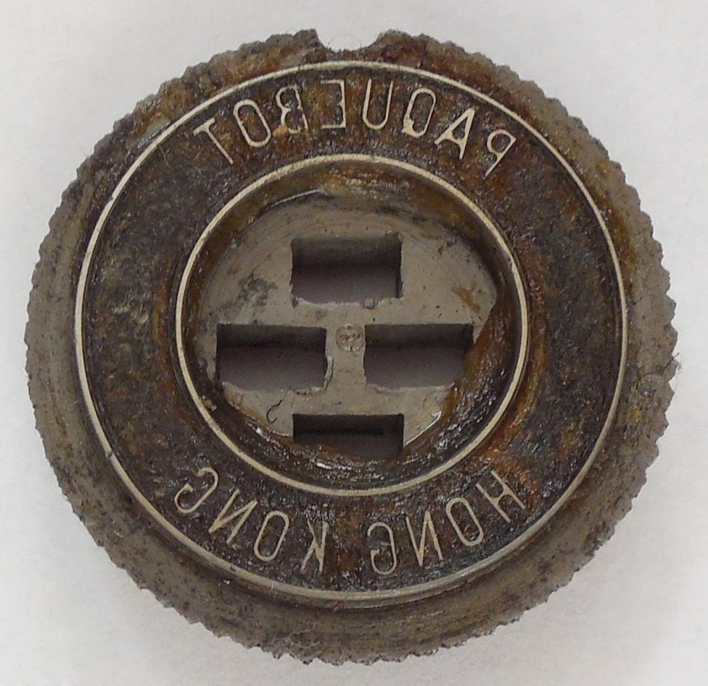

Hong Kong 3112, used 1952 – 1995

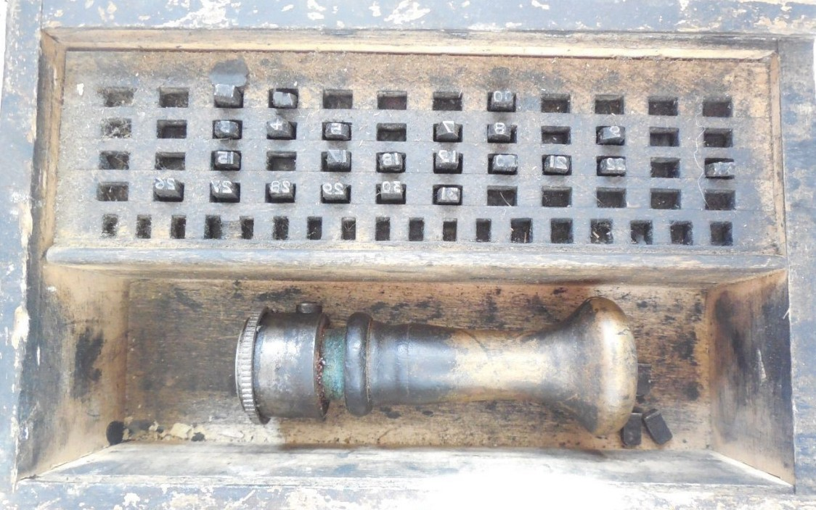

Hong Kong 3112, wooden box

